**CAR PROJECT REPORT** (3rd draft)

**Members:**

* Niket Kumar Saraf
* Daya Sagar Sahu
* Aryan Gurjar Banke
* Rushil Verma
* Saurabh Singh

**Specifications:**

* Height -
* Length -
* Breadth -
* Ground clearance -
* Weight -
* Max speed -
* Battery life –

**Features:**

* High ground clearance
* 4 wheel drive and 2 wheel drive
* Splash proof
* Fast response
* Omni directional movement
* High torque
* Sufficient traction
* Suspension
* Wireless controlling by mobile application
* Speed controlling

**Materials used:**

* One Node MCU
* One Arduino UNO
* Two L298 motor controllers
* Four 12V Johnson DC geared motor with 500 rpm, stall torque 6kgcm, no load current 0.8A(max), load current 9A(max)
* Four 1:10 RC Monster Truck tires 12mm?
* Four 1/18 Metal shock absorbers 65mm?
* Custom designed metal chassis (having upper and lower parts for complete covering and splash proofing)
* One 14.8V 6600 mAH battery
* 15V 1A DC Adapter

**Other things that we tried and reasons to not use them:**

* Arduino UNO + ESP 8266

Problem - High delay and slow response

* Webmos D1 ESP8266 Development Board

Problem -

* 1:10 RC model Rubber tires

Problem - Low traction and inadequate ground clearance

* Commercially available chassis

Problem - Does not meet our design requirements

* 12 V DC geared motor 300 rpm, 1.5 kg-cm

Problem - Insufficient power and torque

* Blink pick and drop application

Problem - Delayed response and connection problem

* Battery level indicator

Problem - We tried to make our structure splash proof and attaching of battery level indicator would lead to many holes in upper chassis from where the water could seep into our circuit

**Issues in chassis designing and their solutions:**

Commercially available chassis did not meet following requirements

* Splash proof body which can’t be achieved due to many unnecessary holes
* External axel shaft required so that shock absorbers can be attached
* So, we went to make our own customized chassis and axel which can be seen in the below photos

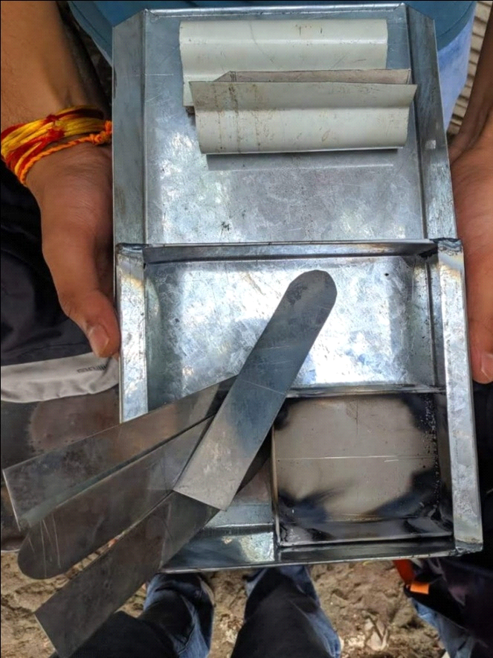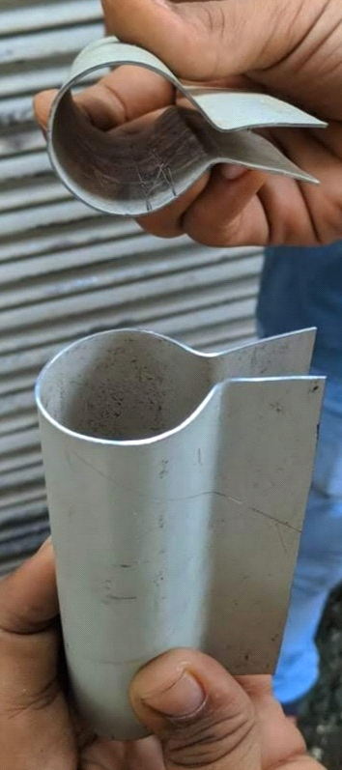

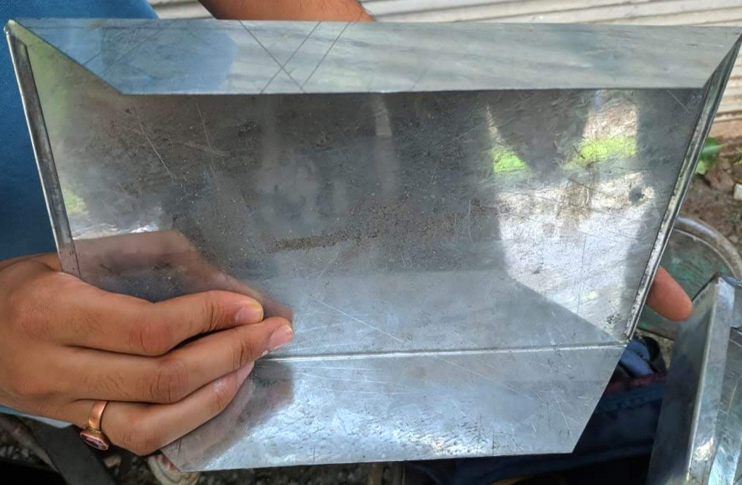

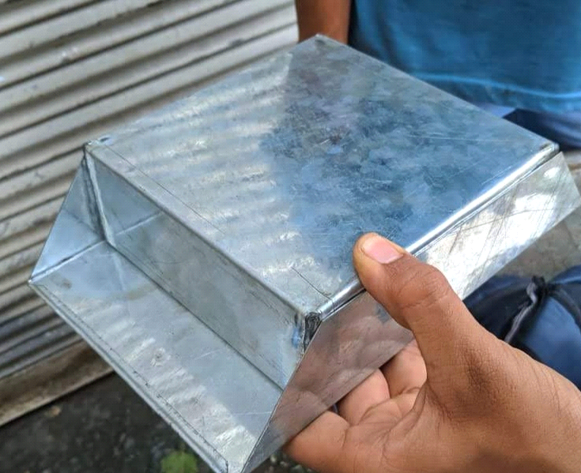 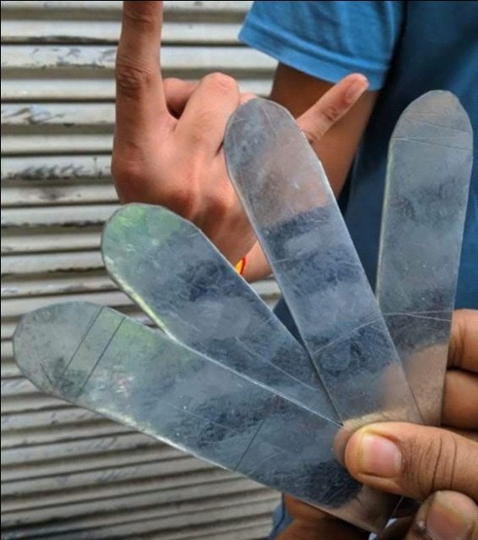



The main problem with this chassis (that we realized after our car completion) is that it weighted too much and hence decreased the car’s performance.

**Circuit Designing:**

Circuit design can be understood with the following points

* We had a heavy duty dc geared motor with stall torque 6kgcm for pulling heavy weight RC car even on the inclined planes, ditches with ease. Although it provided max load current of 9A but we did a laboratory test which concluded that we need not more than 2A.

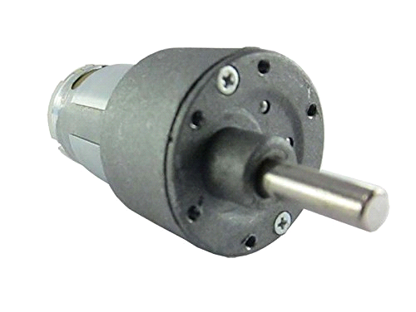

* That's why we used two L298N H-bridge motor drivers which provided 2A per bridge maximum current, 25W max power consumption per board . One board can drive two motors. It could provide direction control, speed control through PWM. It can provide 5v output voltage that we used as power supply for Arduino UNO. it could be powered using 5V-35V power supply*.*

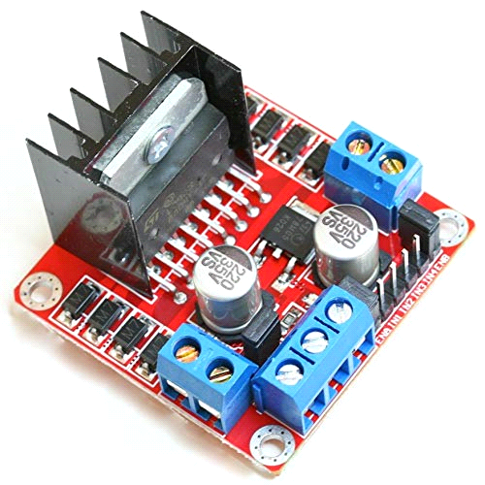

* To power this powerful monster RC car we used one 14.6v 6600Mah Li-ion battery consisting of 12 cells each having 3.7 volts. It has long-life upto 1000 charging cycles. It is provided with inbuilt charging and discharging protection circuit.
* To control this whole set up we used Arduino UNO as controlling unit. The specifications of Arduino UNO is given below.

|  |  |
| --- | --- |
| Microcontroller | [ATmega328P](https://components101.com/microcontrollers/atmega328p-pinout-features-datasheet) – 8 bit AVR family microcontroller |
| Operating Voltage | 5V |
| Recommended Input Voltage | 7-12V |
| Input Voltage Limits | 6-20V |
| Analog Input Pins | 6 (A0 – A5) |
| Digital I/O Pins | 14 (Out of which 6 provide PWM output) |
| DC Current on I/O Pins | 40 mA |
| DC Current on 3.3V Pin | 50 mA |
| Flash Memory | 32 KB (0.5 KB is used for Bootloader) |
| SRAM | 2 KB |
| EEPROM | 1 KB |
| Frequency (Clock Speed) | 16 MHz |

* The pin diagram is shown below.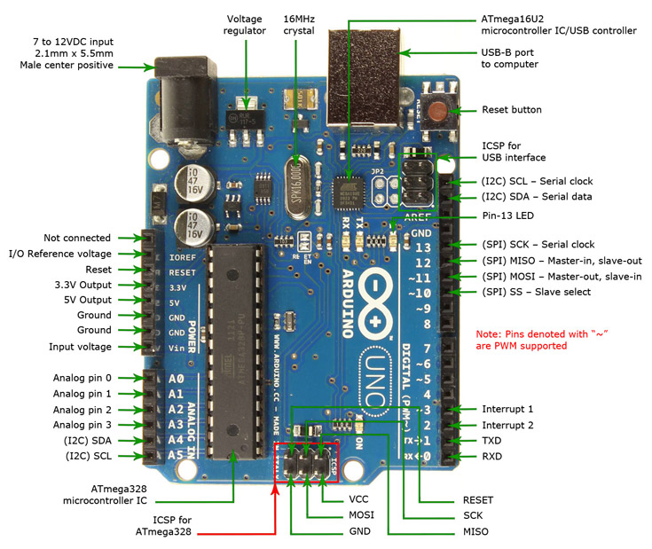
* For communication with the mobile app Nodemcu board was used. It uses wifi for communication. The specifications are mentioned below.

1. Microcontroller: Tensilica 32-bit RISC CPU Xtensa LX106
2. Operating Voltage: 3.3V
3. Input Voltage: 7-12V
4. Digital I/O Pins (DIO): 16
5. Analog Input Pins (ADC): 1
6. UARTs: 1
7. SPIs: 1
8. I2Cs: 1
9. Flash Memory: 4 MB
10. SRAM: 64 KB
11. Clock Speed: 80 MHz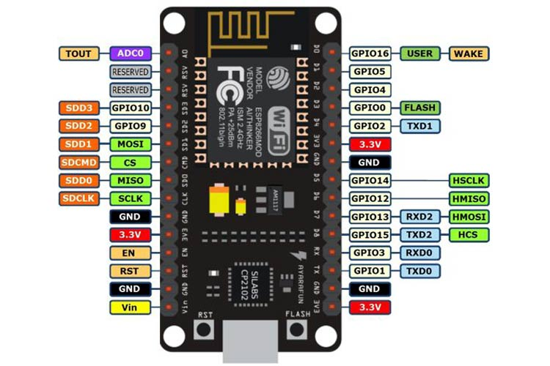

**Circuit Diagram:**

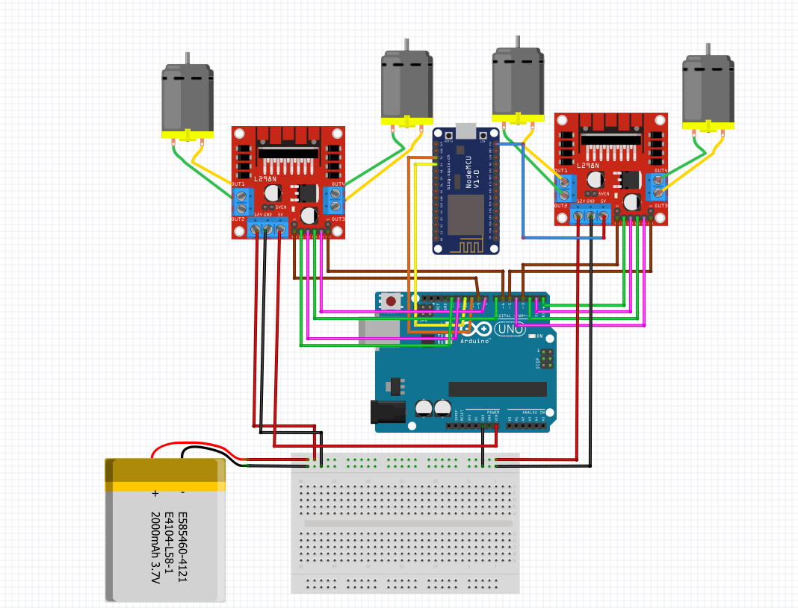

**Possible improvements:**

* Arduino+Esp8266/Nodemcu combination could be replaced by a single development board to provide less delay, less cost and less surface area
* Instead of using metal chassis, 3D printed chassis could be used to decrease weight and hence providing ease of movement.
* Required shaft and tyre hexagonal rings (commercially unavailable) could be 3D printed.